**Lab 04**



**Circuits and System 1 lab**

Submitted by: **Maaz Habib**

Registration No. :**20PWCSE1952**

Class Section: **C**

“On my honor, as student of University of Engineering and Technology, I have neither given nor received unauthorized assistance on this work.”

Submitted to**: Engr Faiz Ullah**

Month Day, Year (May 24, 2021)

Department of Computer Systems Engineering

University of Engineering and Technology, Peshawar

Experiment # 4

Objectives:

* To verify Kirchhoff’s Current Law (KCL) using electrical simulation tool PSPICE

## **Kirchhoff's current law:**

[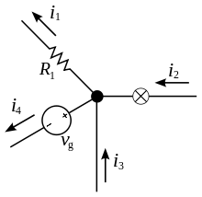](https://en.wikipedia.org/wiki/File:KCL_-_Kirchhoff%27s_circuit_laws.svg)

The current entering any junction is equal to the current leaving that junction. ***i*2 + *i*3 = *i*1 + *i*4**

This law is also represented by **Kirchhoff's first law**, **Kirchhoff's point rule**, or **Kirchhoff's junction rule** or **nodal rule**. It states that for any node or junction

**“In an electric current, the sum of currents flowing into that node is equal to the sum of currents flowing out of that node or equivalently, *the algebraic sum of currents in a network of conductors meeting at a point is zero.”***

{\displaystyle \sum _{k=1}^{n}{I}_{k}=0}

This law is based on conservation of charge, where the charges are measured in coulombs. The product of the current in amperes and time in seconds. If the net charge in a region is constant, the current law will hold on the boundaries of the region.

### Uses:

These law are used in a [matrix](https://en.wikipedia.org/wiki/Matrix_(mathematics)) version of Kirchhoff's current law which are the basic of most [circuit simulation software](https://en.wikipedia.org/wiki/Electronic_circuit_simulation). The current law is used with [Ohm's law](https://en.wikipedia.org/wiki/Ohm%27s_law) to perform [nodal analysis](https://en.wikipedia.org/wiki/Nodal_analysis). The current law is applicable to any lumped network irrespective of the nature of the network.

PSPICE:

It is a circuit analysis tool that allows the user to simulate a circuit and extract key voltages and current. Information is entered into PSPICE from one of the two methods.

* First method is they are typed as 'Net List'.
* The second method is by designing a visual, which is transformed into a netlist.

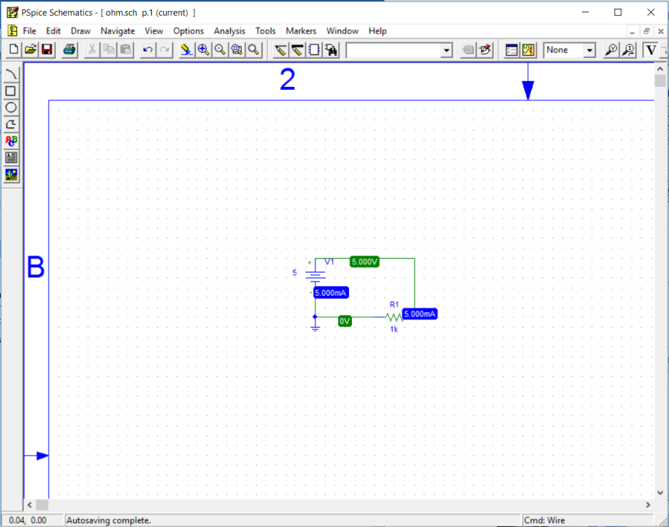

Procedure:

1. Open schematic program of PSpice.
2. In the toolbar, click on the **Get New Part** button.
3. Then type **r** in the search bar and place three the resistors on the white sheet.
4. Then type **vdc** in the search bar and place it on the white sheet.
5. After that type **gnd-earth** in the search and place it on the white sheet.
6. Now arrange these components on the white sheet according to the circuit diagram as following:

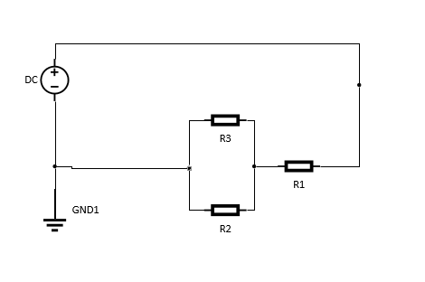

**Figure 2: KCL circuit**

1. Click on the simulation button in the toolbar. Make sure that the voltage and current biase buttons are pressed so that you can take readings of the circuit.

Observation (Case 1: Same resistors):

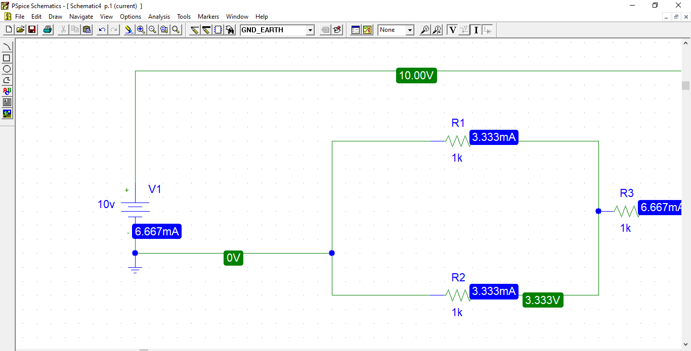

Figure 3 KCL on PSpice (Same Resistors)

|  |  |  |
| --- | --- | --- |
| S.no. | Resistors | Currents |
| 4. | 1k | 3.33mA |
| 5. | 1k | 3.33mA |
| 6. | 1k | 6.667mA |

Observation (Case 2: Different resistors):

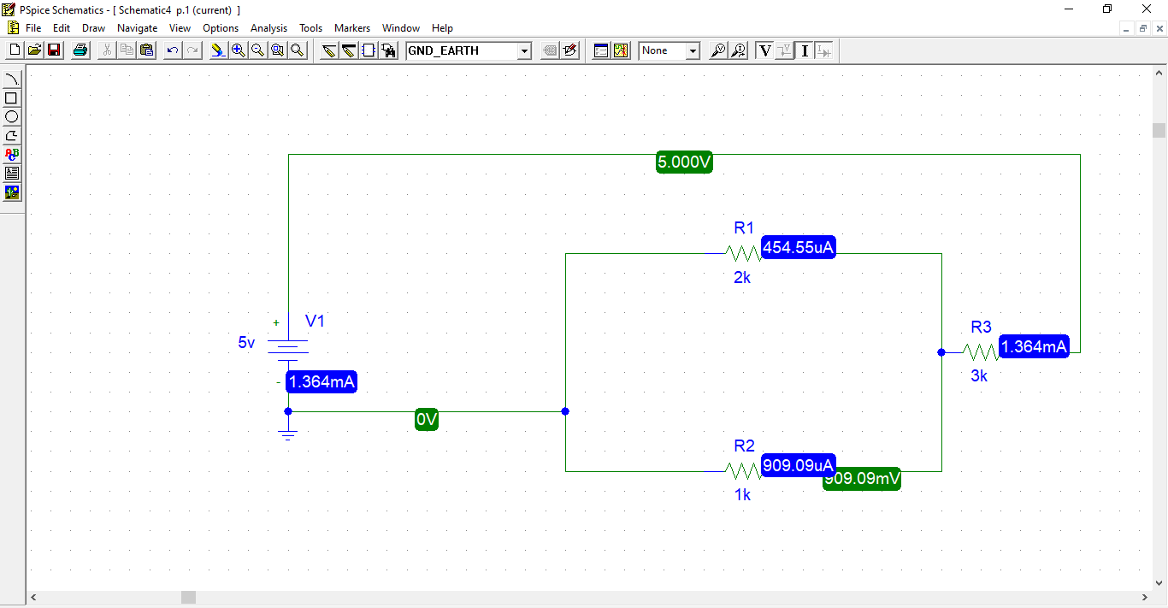

Figure 4: KCL PSpice (Different Resistors)

|  |  |  |
| --- | --- | --- |
| **S.no.** | **Resistors** | **Currents** |
| 4. | 1k | 909.09uA |
| 5. | 2k | 454.55uA |
| 6. | 3k | 1.364mA |

Analysis and discussion about experimental results:

From the experiment we perform (case 1) we observed that the current entering to this node is equal to the current going out. When we changed the resistor in case 2 and simulate again we observed that the current entering the node is not equal to the current flowing out of it.